**Larger-scale prescribed burn project continues around Magalia**

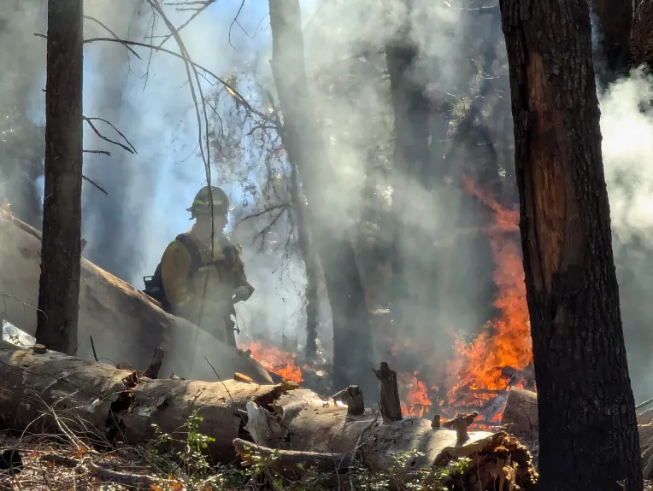A member of Terra Fuego stands beside a burn pile outside of Magalia, California on Monday, Dec. 2, 2024.

(Jake Hutchison/Enterprise-Record)

By [**Jake Hutchison**](https://www.chicoer.com/author/jake-hutchison/) | [jhutchison@chicoer.com](mailto:jhutchison@chicoer.com) | Chico Enterprise-Record

PUBLISHED: December 3, 2024 at 4:30 AM PST

MAGALIA — The cool air and minimal winds on Monday made for good conditions for pile burns in the east part of Butte County.

Prescribed burning is set to continue this week as planned by the Butte Fire Safe Council and conducted by Terra Fuego, a nonprofit organization that focuses on wildfire mitigation through fuel reduction.

Monday’s burn occurred in the woods just east of the Magalia Reservoir. Taylor Nilsson, executive director of the council, said the larger project aims and reducing fuels and making fire breaks around the Magalia community.

“We have pile burns planned on Paradise Irrigation District land and the Paradise Pines Property Owners Association land,” Nilsson said. “And then there are other planned projects outside of these pile burn projects that include broadcast burning as well as additional pile burning supporting the U.S. Forest Service on Forest Service land.”

Piles of biological debris burn near Magalia, California on Monday, Dec. 2, 2024. (Jake Hutchison/Enterprise-Record)

The pile burn project comes out to 109 acres of land scattered around Magalia and the reservoir with an additional 200 acres working with the Forest Service. More pile burns are planned toward northern Magalia further up the Skyway.

Terra Fuego has consistently been a partner with the council in making prescribed burns happen. The locations are tactical and planned to create buffers for when wildfire does occur.

“There are a lot of hurdles to reintroducing fire, and so being able to work with partners like Terra Fuego is important because they are able to have a burn boss on staff and work with us and be able to figure out all of those complexities which is crucial,” Nilsson said.

The council and its partners have also been working to communicate with the public regarding prescribed burns. Signs were set up along the Skway well before the staging area on Coutolenc Road informing drivers that the burn was occurring and that smoke would be normal while also urging them not to call 911, tying up the emergency line.

A map of the projected prescribed burn locations around Magalia, California. Burns were conducted on the east side of the Magalia Reservoir on Monday, Dec. 2, 2024. (Butte Fire Safe Council/Contributed)

